Experiment 2
Online hotel room booking
Aim : To develop a simple Hotel Room Booking website that allows users to check room availability, view prices, book or cancel rooms, and manage their bookings. The admin can manage room prices, room quantities, and booking details.

Procedure
- Create a webpage using HTML with hotel details and room types.
- Add a booking form to enter the guest name, check-in date, check-out date, and room type.
- Display room prices and availability.
- Provide options to view booking details and cancel a booking.
- Add admin options to manage room prices and quantities.
- Include contact information, FAQs, and hotel policies.
- Test the webpage to check whether the features work correctly.

Sample Code :

<!DOCTYPE html>
<html>
<head>
<title>Hotel Room Booking</title>
</head>
<body>
<h1>Welcome to Our Hotel</h1>
<p>Book your comfortable stay with us!</p>

<h2>Room Types</h2>
<p>Single Room - ₹1000 per night</p>
<p>Double Room - ₹2000 per night</p>
<p>Deluxe Room - ₹3000 per night</p>

<h2>Book a Room</h2>
<form onsubmit="bookRoom(event)">
<input id="name" placeholder="Guest Name" required><br><br>

<label>Check-in:</label>
<input type="date" id="checkin" required><br><br>

<label>Check-out:</label>
<input type="date" id="checkout" required><br><br>

<select id="room">
<option>Single Room</option>
<option>Double Room</option>
<option>Deluxe Room</option>
</select><br><br>

<button type="submit">Book Now</button>
<button type="reset">Reset</button>
</form>

<h2>Booking Details</h2>
<p id="result">No booking yet.</p>
<button onclick="cancelBooking()">Cancel Booking</button>

<h2>Contact Us</h2>
<p>Email: hotel@example.com</p>
<p>Phone: 9876543210</p>

<script>
function bookRoom(event) {
event.preventDefault();

let name = document.getElementById("name").value;
let start = document.getElementById("checkin").value;
let end = document.getElementById("checkout").value;
let room = document.getElementById("room").value;

if (end <= start) {
alert("Check-out must be after check-in.");
return;
}

document.getElementById("result").innerHTML =
"Guest: " + name + "<br>Room: " + room +
"<br>Check-in: " + start +
"<br>Check-out: " + end;
}

function cancelBooking() {
document.getElementById("result").innerHTML =
"Booking cancelled.";
}
</script>
</body>
</html>
Output :
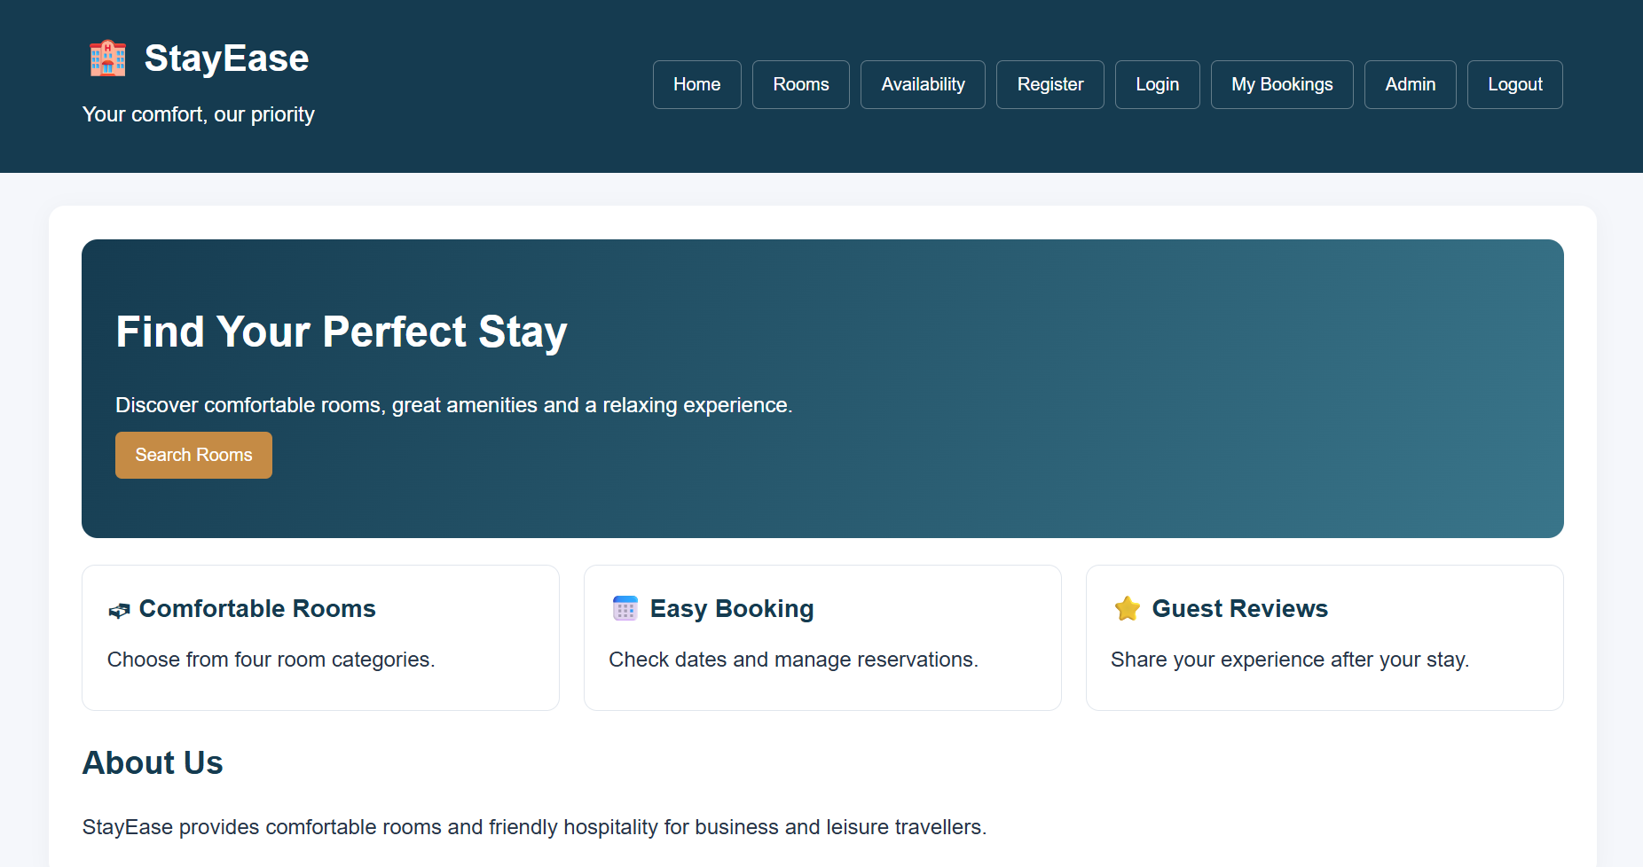

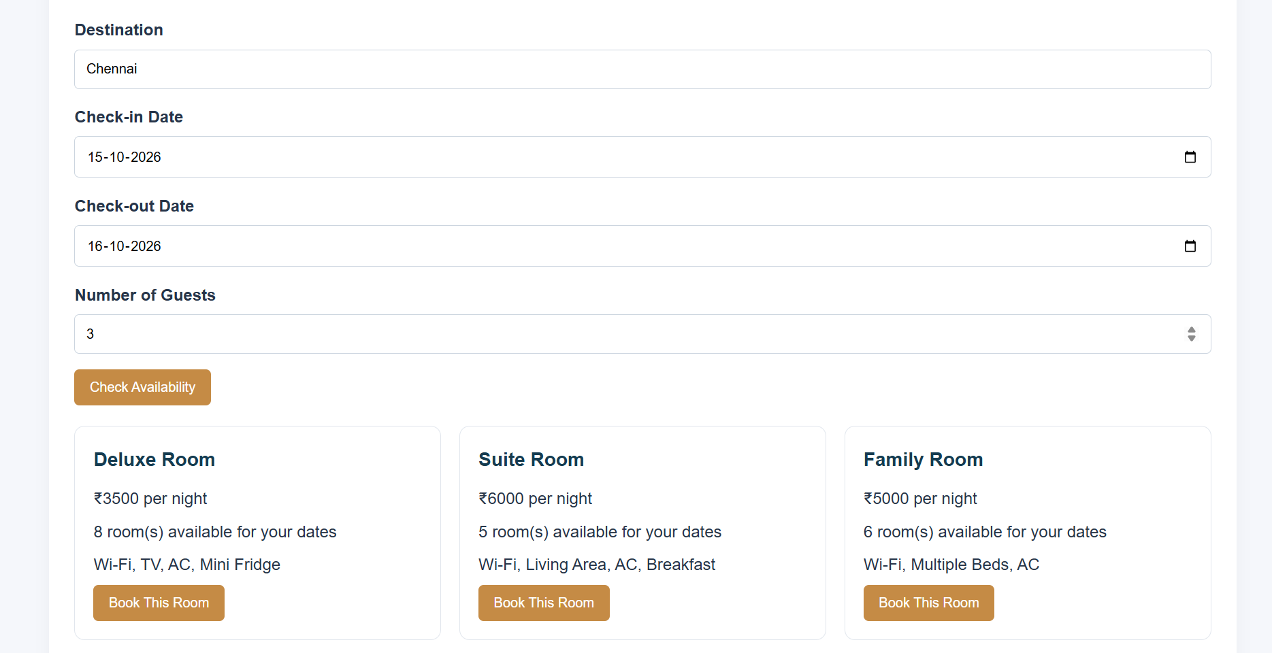

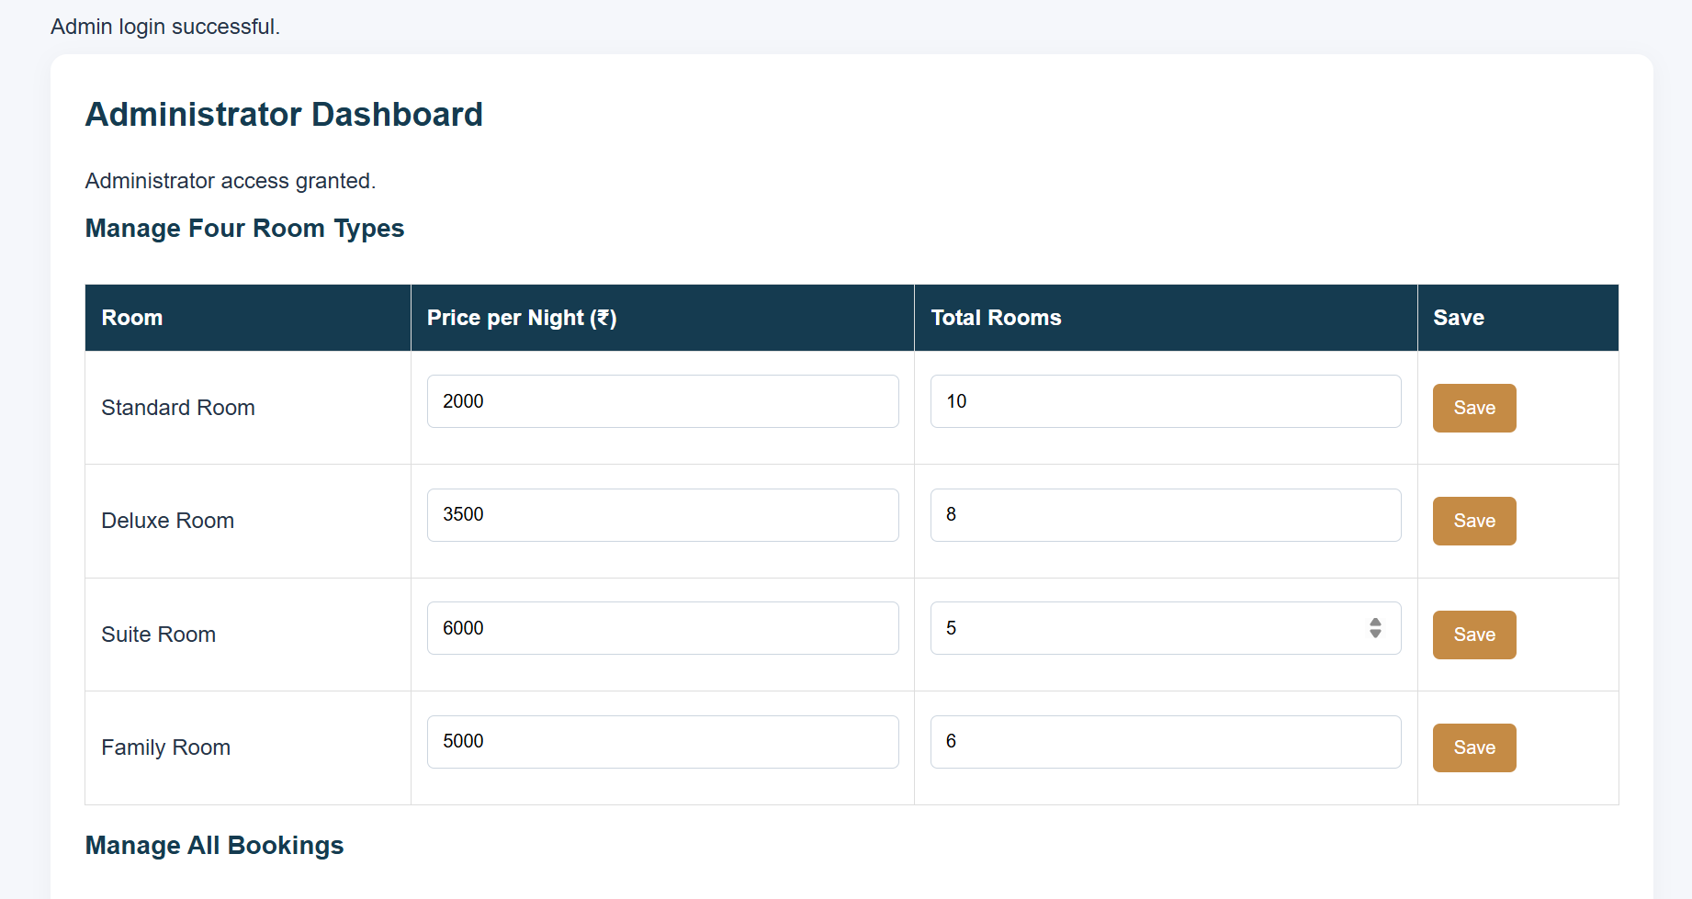

Result :
The Hotel Room Booking website was created successfully. Users can enter their details, select a room, choose check-in and check-out dates, view booking details, and cancel a booking. The sample demonstrates basic booking functionality; real availability checks, secure payments, user accounts, and admin management require a backend and database.

